

Semester 1 Examination 2010

Question/Answer Booklet

MATHEMATICS 3C/3D

Section One

(Calculator Free) Student Number

Name
Teacher ___________________________________

Time allowed for this section
Reading time before commencing work: 5 minutes
Working time for paper: 50 minutes

Material required/recommended for this section

To be provided by the supervisor
Question/answer booklet for Section One.
Formula sheet.

To be provided by the candidate
Standard items: pens, pencils, pencil sharpener, highlighter, eraser, ruler.
Important note to candidates
No other items may be taken into the examination room. It is your responsibility to ensure that you do not have any unauthorised notes or other items of a non-personal nature in the examination room. If you have any unauthorised material with you, hand it to the supervisor before reading any further.

Structure of this examination

 | Number of questions | Working time (minutes) | Marks available
This Section (Section 1)  Calculator Free | 6 | 50 | 40
Section Two  Calculator Assumed | 12 | 100 | 80
Total marks |  |  | 120

Instructions to candidates

- The rules for the conduct of WACE external examinations are detailed in the booklet WACE Examinations Handbook. Sitting this examination implies that you agree to abide by these rules.

- Answer the questions in the spaces provided.

- Spare answer pages are provided at the end of this booklet. If you need to use them, indicate in the original answer space where the answer is continued i.e. give the page number.

- Show all working clearly. Any question, or part question, worth more than 2 marks requires valid working or justification to receive full marks. If you repeat an answer to any question, ensure that you cancel the answer you do not wish to have marked.
Section One (calculator-free) 40 Marks
This section has five (5) questions. Answer all questions. Write your answers in the space provided.

Spare pages are included at the end of this booklet. They can be used for planning your responses and/or as additional space if required to continue an answer.
  - Planning: If you use the spare pages for planning, indicate this clearly at the top of the page.
  - Continuing an answer: If you need to use the space to continue an answer, indicate in the original answer space where the answer is continued, i.e. give the page number. Fill in the number of the question(s) that you are continuing to answer at the top of the page.

Suggested working time for this section is 50 minutes.

Question 1 (9 marks)
The velocity, V (t) metres per second, at a time t seconds, of an object moving along a straight line for a period of 10 seconds is given by
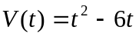

a) Find the formula for 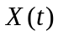, the displacement at time t, given that 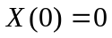. (1 mark)

b) At what time in the period 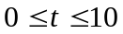does the object return to its starting point? (2 marks)

c) At what time in the period is the object furthest away from its starting point? (2 marks)

d) At what time in the period is the object moving towards its starting point? (2 marks)

e) How far does the object travel in the period ? (2 marks)
Question 2 (7 marks)
(a) Express with a common denominator and simplify
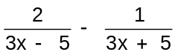 (3 marks)

(b) Simplify: 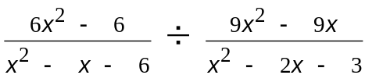 (4 marks)
Question 3 (5 marks)
For each of the following find the derivative with respect to x:
(a) 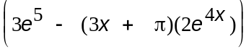 (2 marks)

(b) 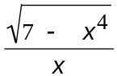 (Do not simplify your answer but express your answer with
positive exponents) (3 marks)

Question 4 (4 marks)
(a) 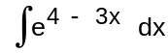 (1 mark)

(b) 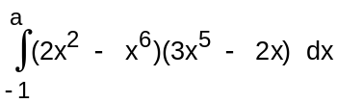 (3 marks)

Question 5 (6 marks)
a) Make a sketch showing the graphs of and 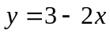 indicating clearly on your sketch the co-ordinates of any points where the functions intersect the axes and each other. (3 marks)

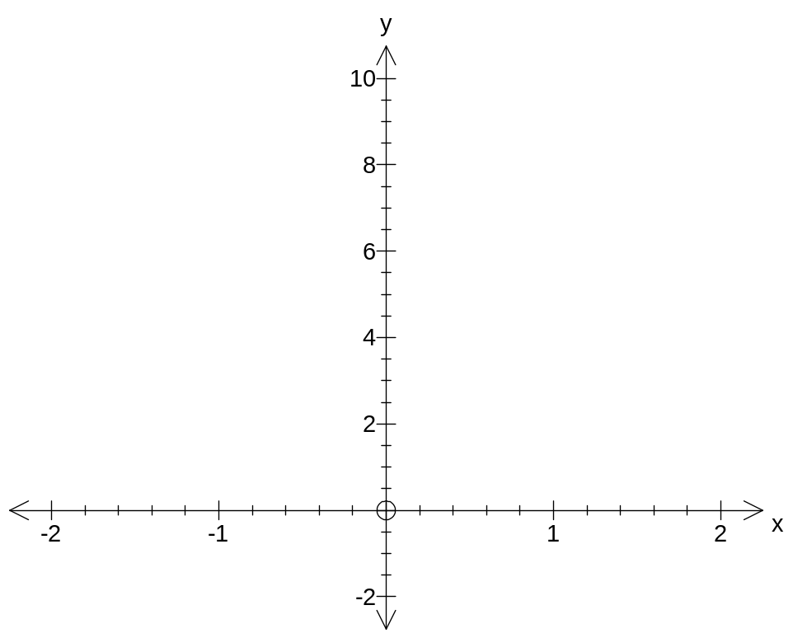

b) Find the area enclosed between and (3 marks)

Question 6 (9 marks)
P(A) = 0.2, P(B) = x and P(A ∪ B) = p.
(a) Find in terms of x, p and/or any numeric value
(i) P(A ∩ B) (1 mark)

(ii) P( ∪ B) (2 marks)

(b) If event A is a subset of event B determine a numeric range of values for p. (1 mark)

(c) If x = 0.6, determine for what values of p are
(i) events A and B mutually exclusive? (2 marks)

(ii) events A and B are independent? (3 marks)
Additional working space

Additional working space

